**Experiment No. 4**

Aim: Structured Data Flow Analysis of E-commerce website

Problem Statement: To prepare Data Flow Diagram (DFD) for E-commerce shopping website

Theory:

Analysts use various tools to understand and describe the information system. One of the ways is using structured analysis.

**What is Structured Analysis?**

Structured Analysis is a development method that allows the analyst to understand the system and its activities in a logical way.

It is a systematic approach, which uses graphical tools that analyse and refine the objectives of an existing system and develop a new system specification which can be easily understandable by user.

It has following attributes −

* It is graphic which specifies the presentation of application.
* It divides the processes so that it gives a clear picture of system flow.
* It is logical rather than physical i.e., the elements of system do not depend on vendor or hardware.
* It is an approach that works from high-level overviews to lower-level details.

**Data Flow Diagrams (DFD) or Bubble Chart**

It is a technique developed by Larry Constantine to express the requirements of system in a graphical form.

* It shows the flow of data between various functions of system and specifies how the current system is implemented.
* It is an initial stage of design phase that functionally divides the requirement specifications down to the lowest level of detail.
* Its graphical nature makes it a good communication tool between user and analyst or analyst and system designer.
* It gives an overview of what data a system processes, what transformations are performed, what data are stored, what results are produced and where they flow.

**Basic Elements of DFD**

DFD is easy to understand and quite effective when the required design is not clear and the user wants a notational language for communication. However, it requires a large number of iterations for obtaining the most accurate and complete solution.

The following table shows the symbols used in designing a DFD and their significance –

|  |  |  |
| --- | --- | --- |
| **Symbol Name** | **Symbol** | **Meaning** |
| Square | Square | Source or Destination of Data |
| Arrow | Arrow | Data flow |
| Circle | Circle | Process transforming data flow |
| Open Rectangle | Rectangle | Data Store |

**E-Commerce DFD:**

Level 0:

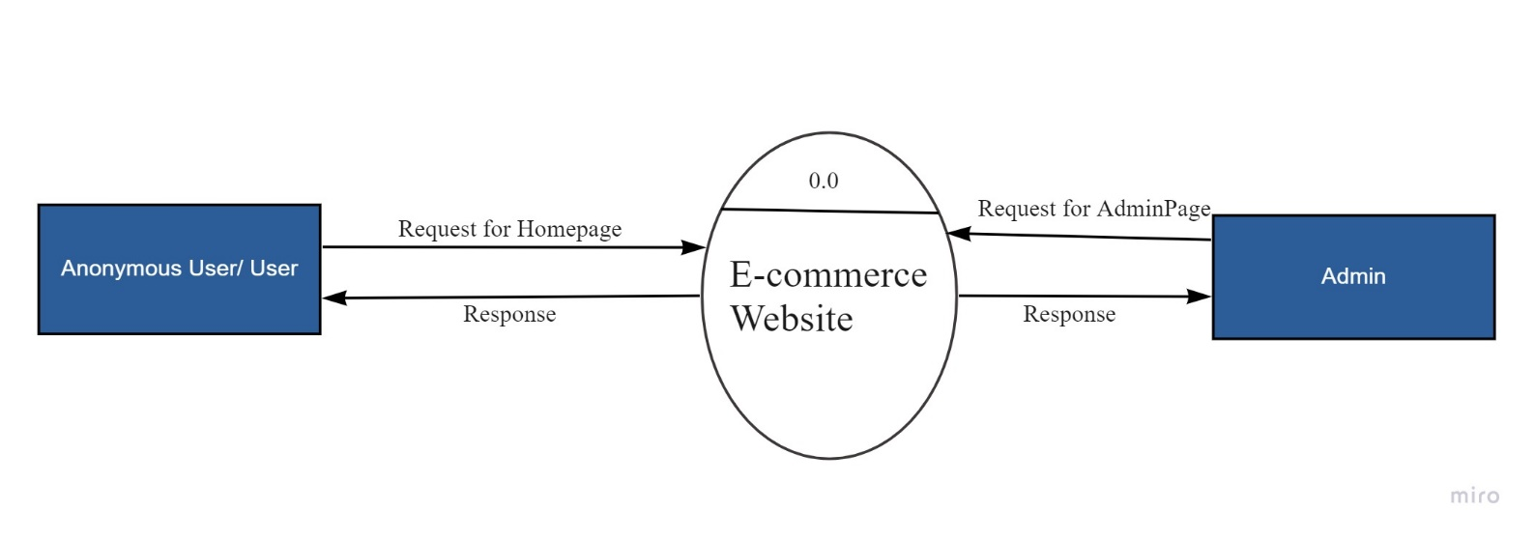

Admin 1st level DFD:

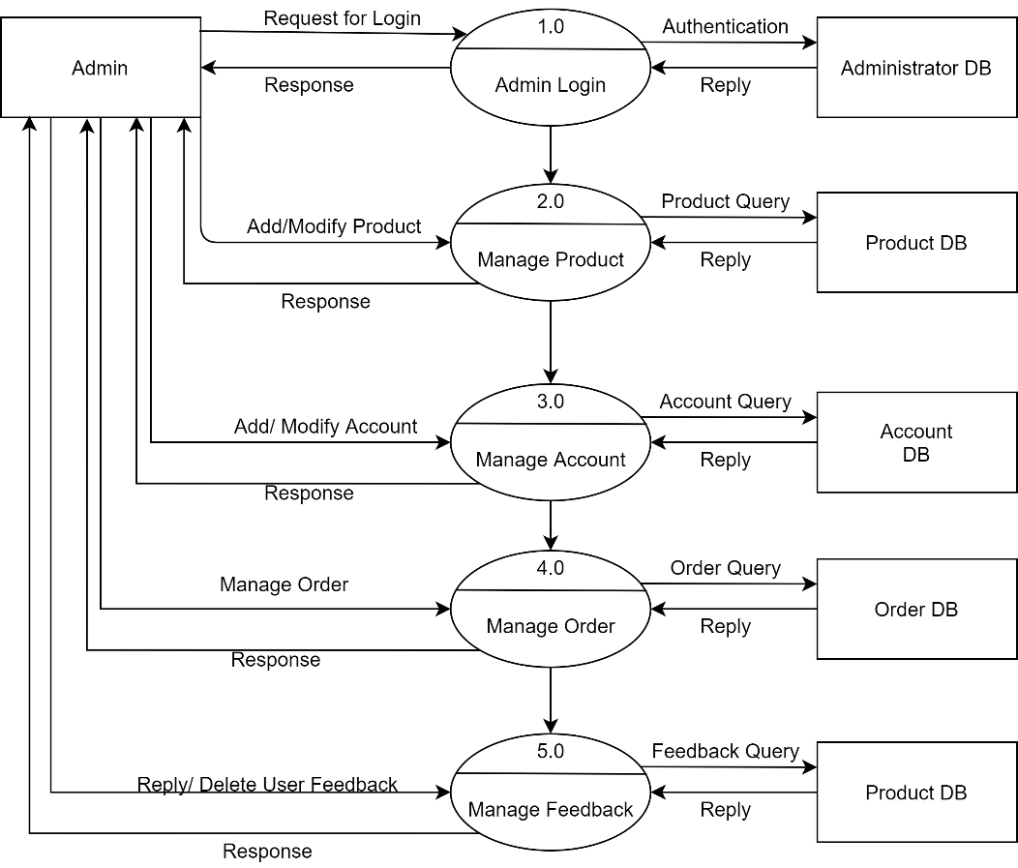

Admin DFD 2.0:

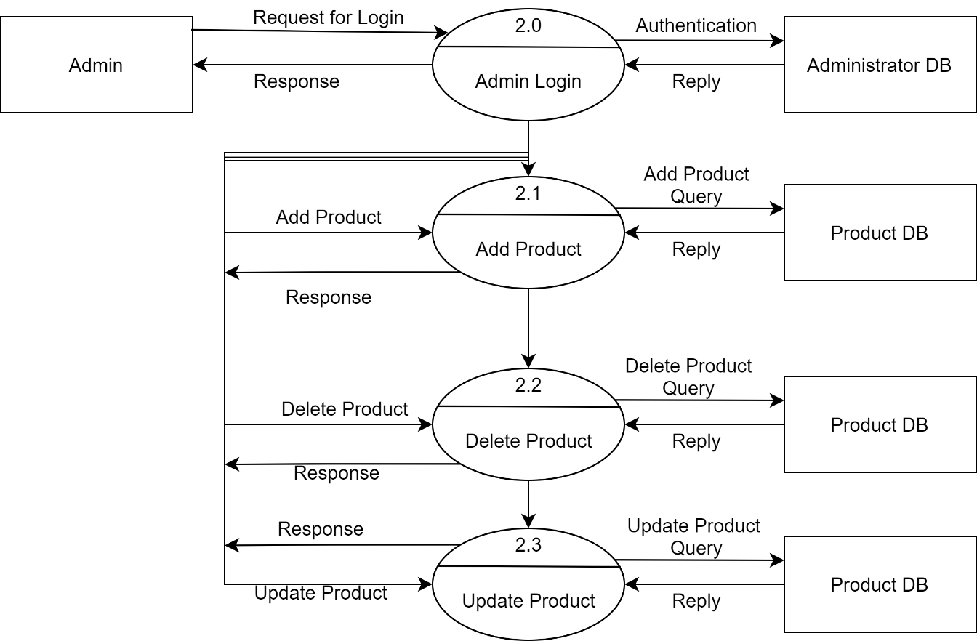

Admin level 3.0:

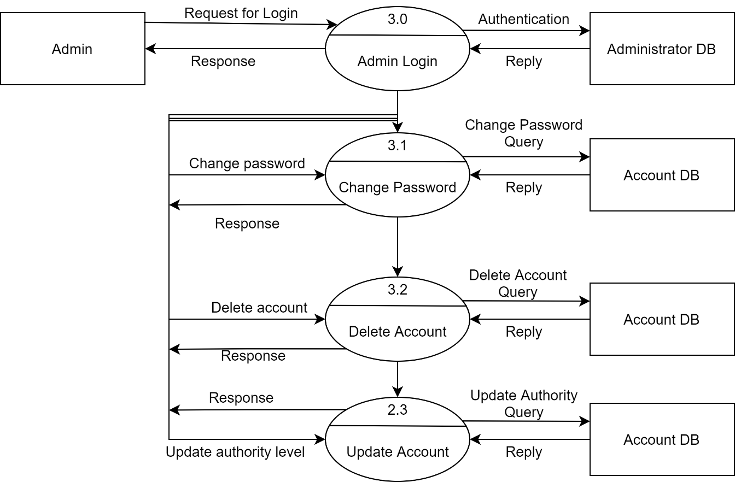

Admin level 4.0:

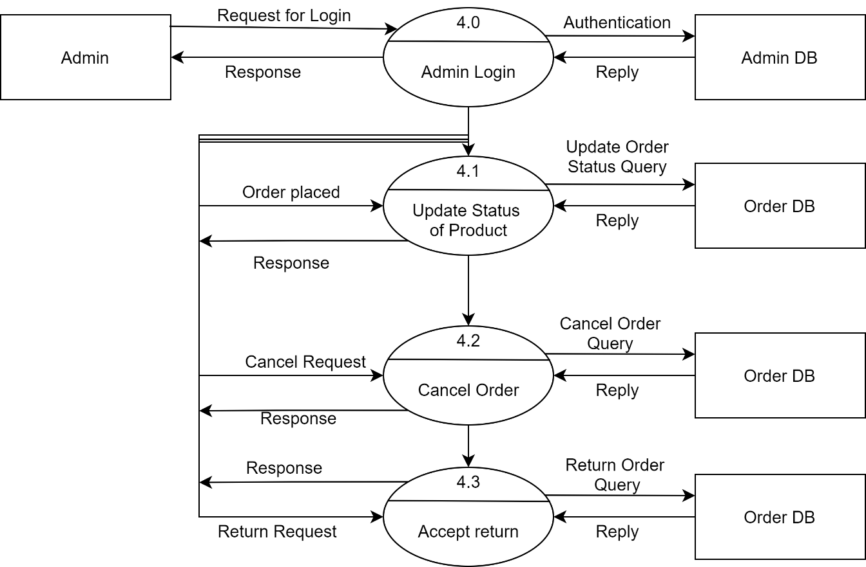

User 1st level DFD:

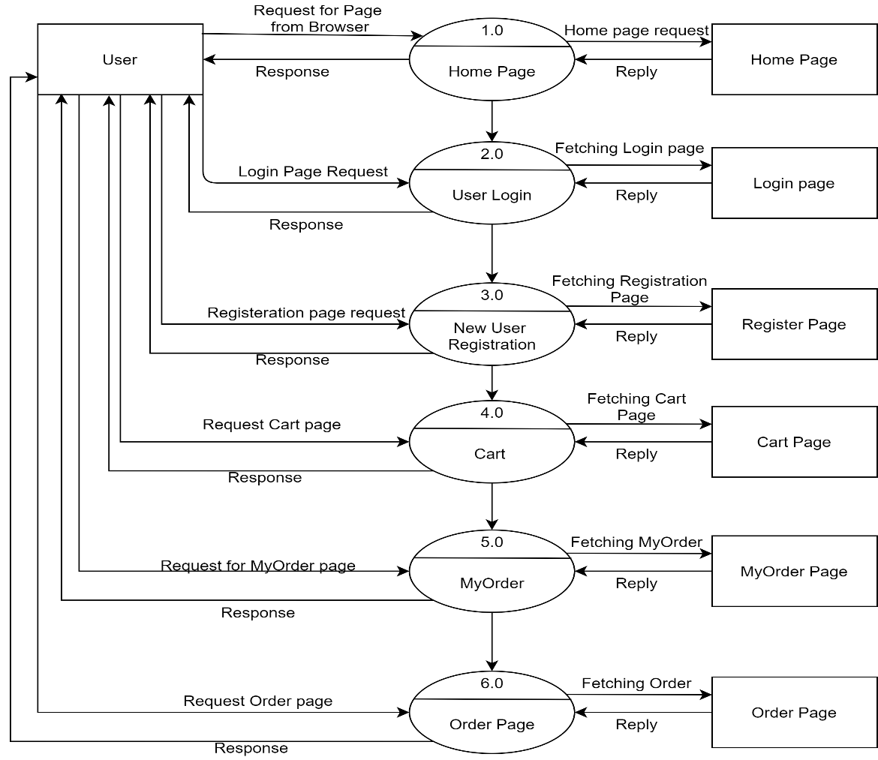

User level 1.0:

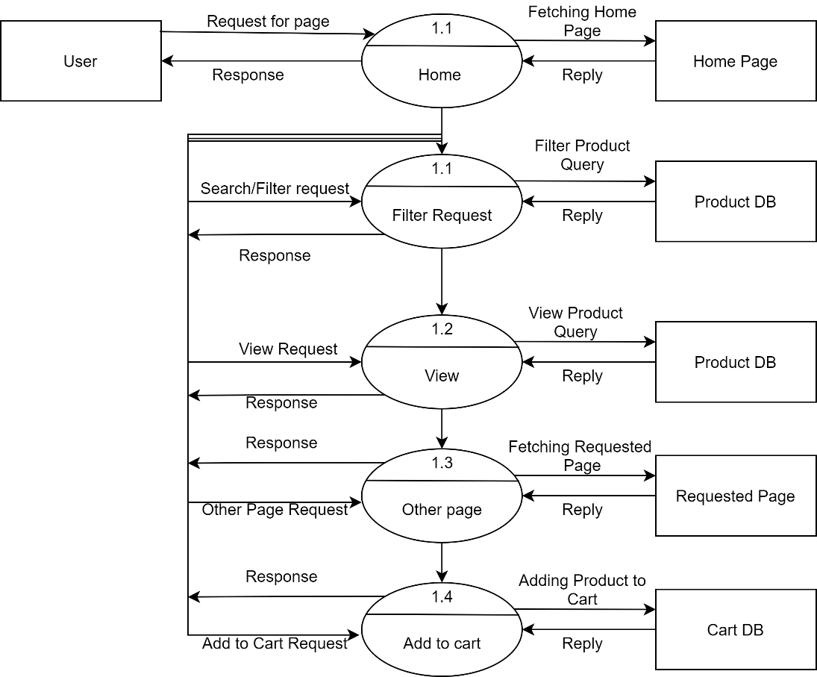

User level 2.0:

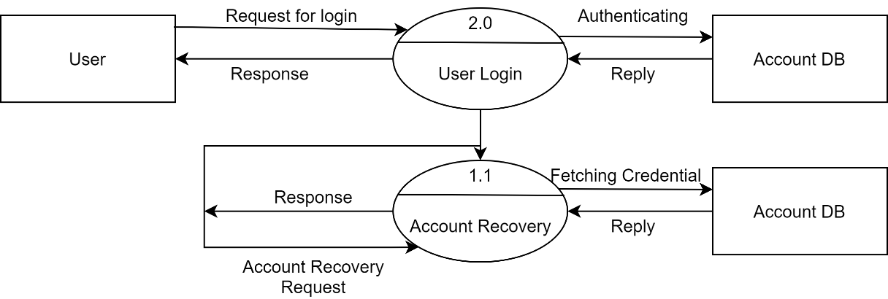

User level 4.0:

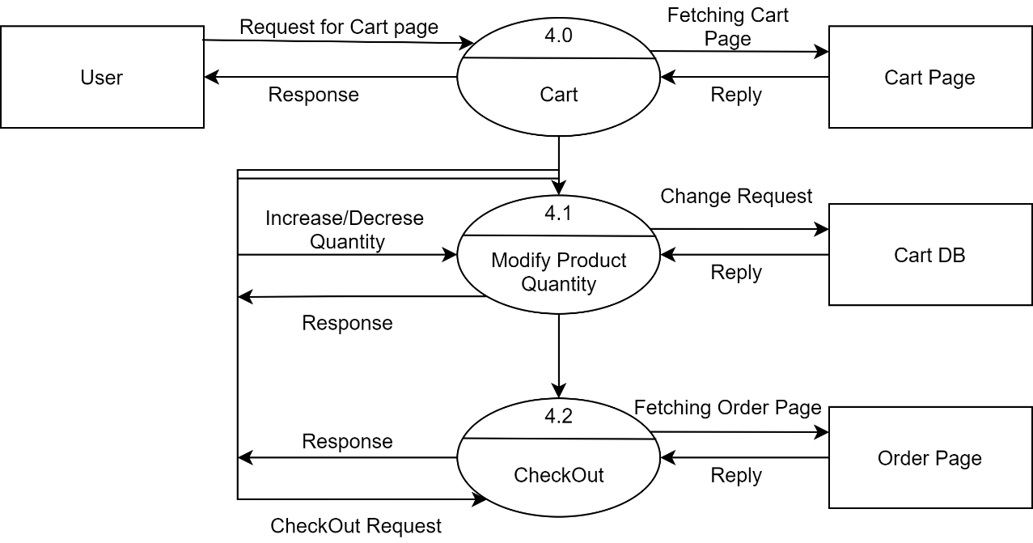

User level 5.0:

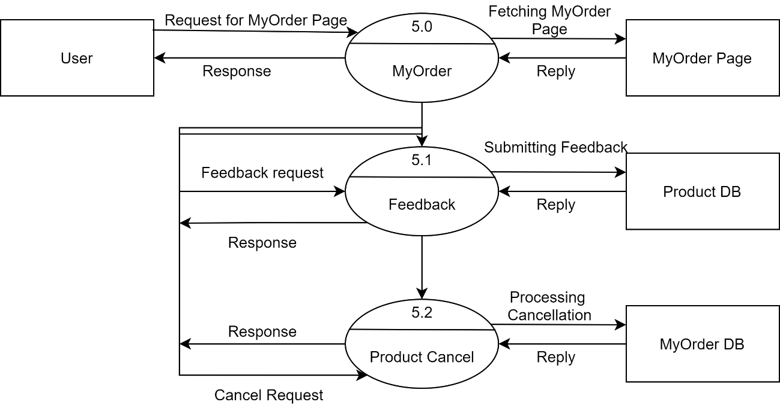

User level 6.0:

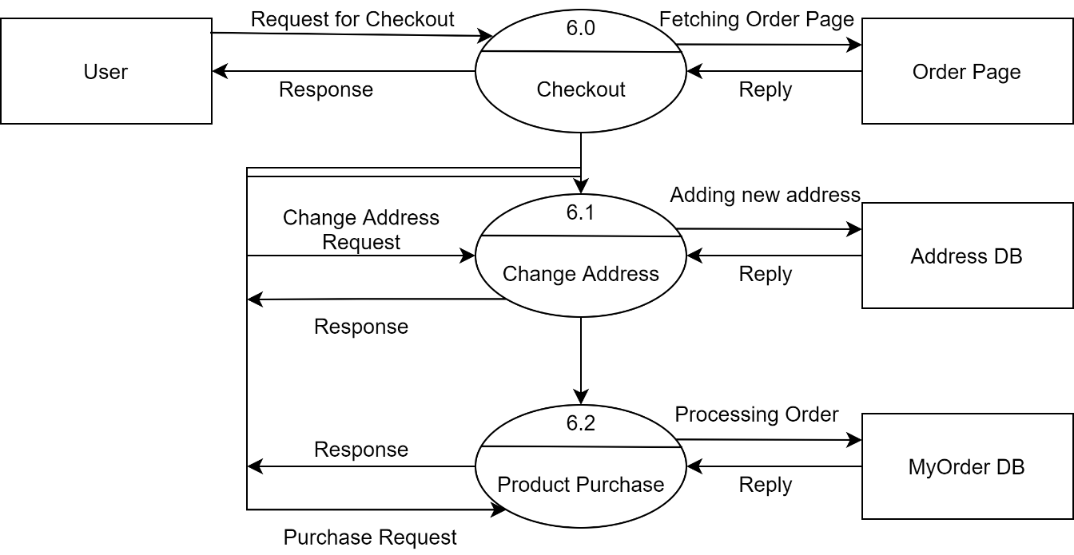

Conclusion: We have successfully learnt the concept of Structure Data Flow Analysis and how to implement it using Data Flow Diagram on E-commerce Shopping Website.